Sprint and Marathon Canadian Canoe Training Day

Saturday 16 October
10.00 – 16.00
Richmond Canoe Club

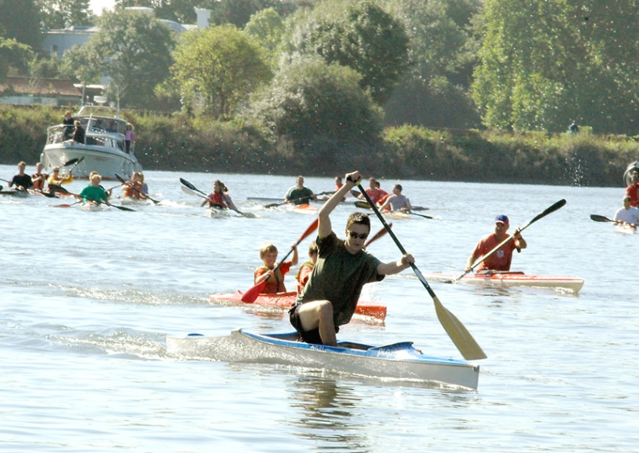
Photo: Neil Thomas

Open to all. We will provide:

- Sessions for experienced paddlers wanting to train with other canoes, with advice on technique.
- Coaching on technique for less experienced paddlers.
- Advice for novices and coaches on the basic stroke, equipment, how to set up the boat and correct position in the boat.
- A variety of boats of varying degrees of stability to try.
- Canoe paddling machines for bank-based technique analysis.
- Other equipment such as paddles and knee blocks.

Cost is free
Please bring changes of paddling kit appropriate for the conditions on the day, and a boat and paddle if you have one.
For more details contact Marcus Gohar,Marcus.gohar@canoe-england.org.uk Phone 07794051301

Venue

Richmond Canoe Club
Landsdowne Boathouse
81-83 Petersham Road
Richmond upon Thames
Surrey TW10 6UT
http://www.richmondcanoeclub.com/

Parking is always a problem. River lane, about 1Km by road and 700 metres by river, may be the best option.

