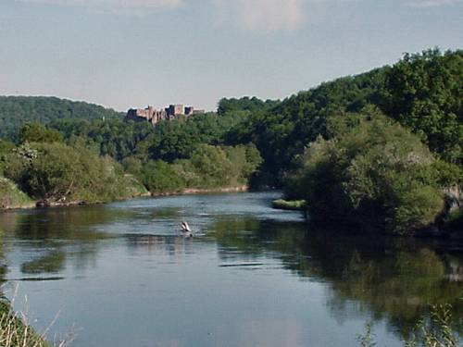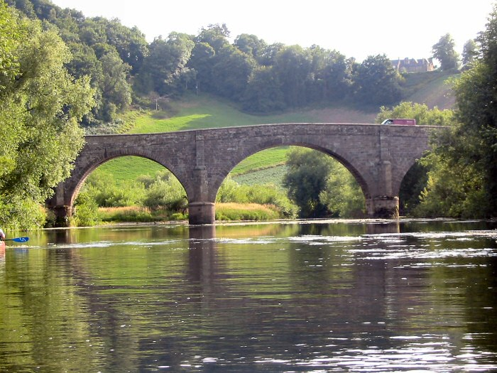

BP4 – Wye not?
River Wye
Sunday 11 July – Friday 16 July 2010

The annual “Big Paddle” will soon be upon us again. This year the RCC tour committee is arranging a trip of about 85 miles over four days down the beautiful river Wye, starting from above Hay-on-Wye and ending around Tintern Abbey, shortly before the river runs into the Severn estuary.

The Arrangements
As in previous years, transport will be pooled. We will mainly be camping, but plan to stay a couple of nights in B&B if we can find suitable locations. Breakfast and food for lunch is provided but you have to buy your own evening meal from a convenient hostelry near our stopping point.

Go for it!
Paddling over 4 days is tough, but, as with the tours, we will match the paddle partners in K2s so the strong paddlers support the less strong and the boats are balanced. The longest day’s paddle is 28 miles. If you are relatively new to paddling, discuss this with your coach or a member of the tour group committee. Don’t be put off!

How much will it cost?
The cost of the week depends on how many people come. The maximum we can take is 16.

It will cost approximately £260 per person (based on 10 people) and £230 per person (based on 16 people). In addition, you would need to allow personal expenditure for evening meals, drinks etc of approximately £15 per day or £90 over the week. If actual costs are less than expected there will be a refund.

You will also need BCU membership to paddle on the Wye and benefit from BCU’s third party insurance cover.

How do I join?
If you would like to attend, please email Jim Mullany as soon as possible. Jim.mullany@hounslow.gov.uk

There will be a meeting at the club to describe the arrangements for the tour and answer any questions after paddling on Saturday 29th May. Further briefings on the arrangements will be issued nearer the event.

To come on the tour you will need to:
- express an interest in joining and pay a non-refundable deposit of £50 by Saturday 5th June.
- pay the full amount due by Saturday 26th June.

If you want further information please speak to one of the organising committee at the club:

Jim Mullany  07912 756492 | Sarah Jefferson  07761 716052
Marie-Do Sanders  07905 605854 | Steve Ogin  07885 181424
Andrew Hunt
07966 549296

