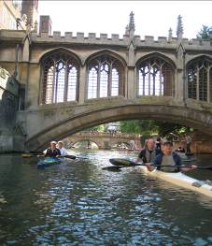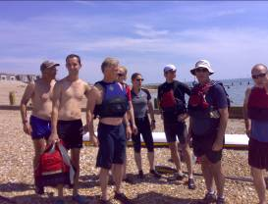

Richmond Canoe Club Tours 2010

2 May | Guildford to Godalming
21 June | River Arun upstream from Pulborough
11 – 17 July | BP4 – Five day paddle down the River Wye
12 September | Chichester Harbour (weather permitting)
3 October | Pangbourne to Wallingford – River Thames
31 October | Basingstoke canal.
Dates and locations may vary.
The tour group aims to explore new stretches of water, and different paddling challenges. It is open to everyone. We meet at the club at about 8.30 and return in the early evening. We share cars, so if you have a car that could be used, and, especially, if you have roof bars that would take v-bars for carrying the kayaks, please let us know.
If you want further information (or don’t have email) please speak to one of the organising committee at the club:

Jim Mullany – 07912 756492 | Sarah Jefferson – 07761 716052
Marie-Do Sanders – 07905 605854 | Steve Ogin – 07885 181424
Andrew Hunt – 07966 549296

To get on our mailing list please email jim.mullany@hounslow.gov.uk and you will automatically received details for each event.

